**Retailers**

Retailers or Customers are the users for whom we work and serve. Retailers module is used to display, edit, block all the retailers of the company.

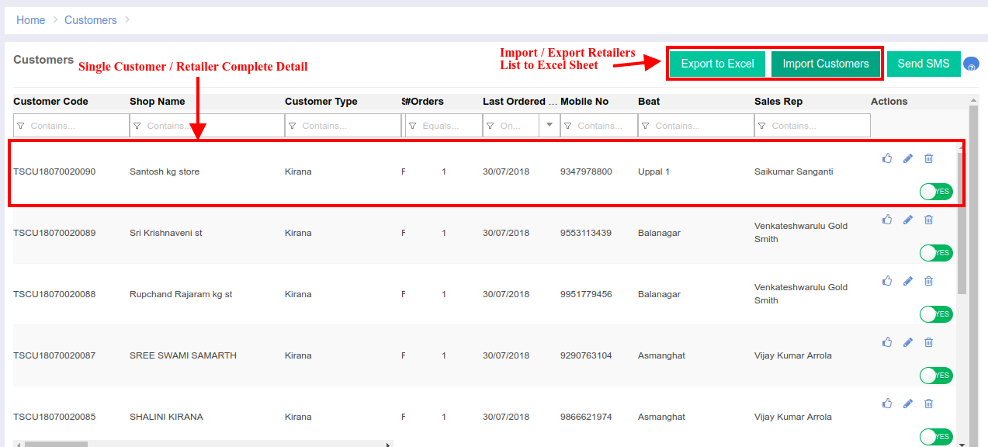

Retailer / Customer Edit Page:  
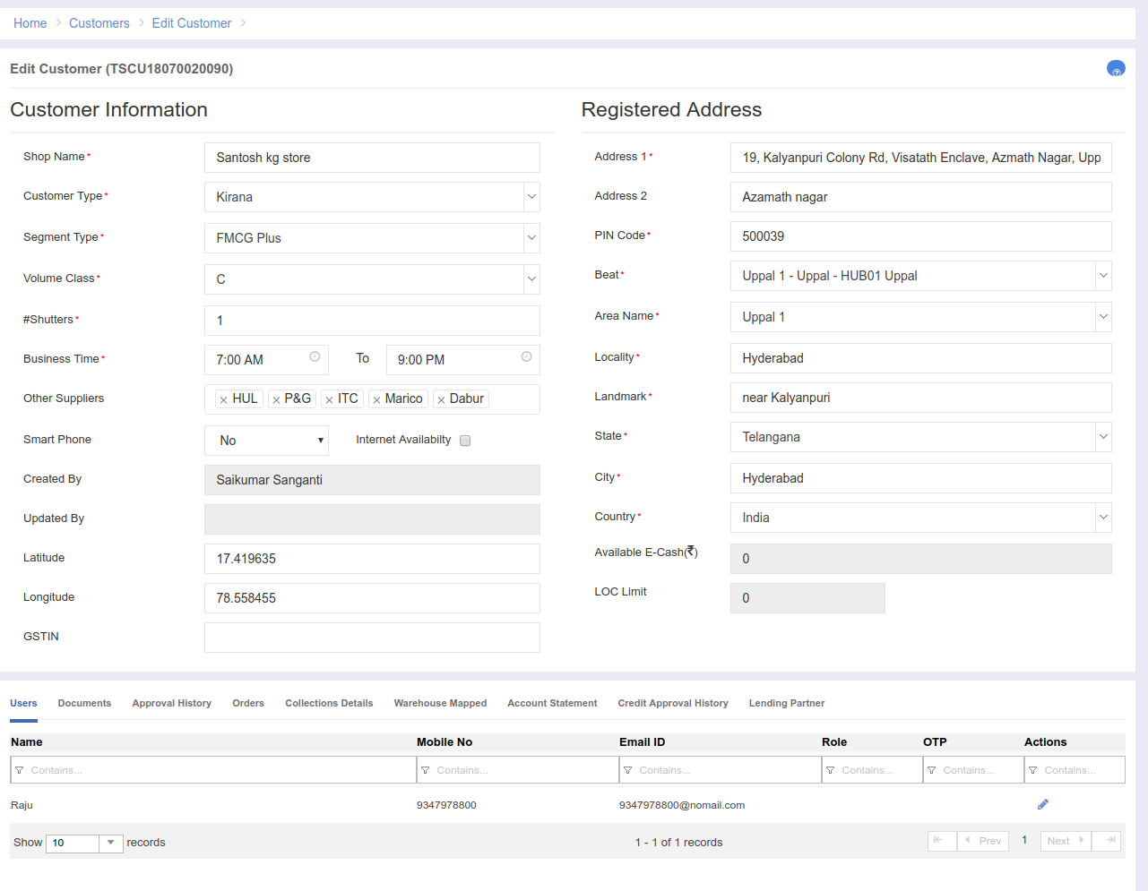

In Retailer edit page, we can see the basic information of the retailer which is editable.

**Users Tab:**  
 A retailer can have multiple users and all those users information is show in this tab.

**Documents Tab:**  
 All the documents related to the retailer like pan card, address proof are shown here.

**Approval History:**  
 The manager who had approved this retailer is display here.

**Orders:**

All the orders placed by this particular retailer are shown here in a grid.

**Collections Details:**  
 All the collections for all the orders placed by the customer are shown here.

**Warehouse Mapped:**  
 The warehouse information which serves this particular retailers is shown here.

**Account Statement:**  
 If the retailer had any cash back which are credited to him/her, they will be shown here.

**Credit Approval History:**

If there are any loans which are taken by the retailer, then that information will be shown here.  
**Lending Partner:**

The partner who gives the loans for that particular retailer are shown here including the amount that the partner had lended to him.

Retailer Excel Export:

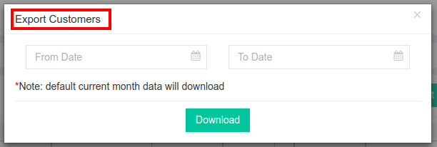  
The date range is to retrieve the list of retailers who are created in between.

Retailer Excel Import:  
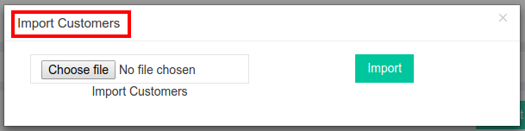  
The retailer excel import option is used to add new retailers in to the system  
  
Code Details:  
 Module Name: **Retailer**

URL: <https://portal.ebutor.com/retailers/index>  
 Database Tables: **retailer_flat** & **legal_entities**

Features:

Credit Limit Permission [UPCL01]

Credit Limit Edit Access [LOCE001]

Edit Old Retailer Permission [RET002]

Delete Old Retailer Permission [RET003]

Approve Retailer Permission [RET004]  
 Block Retailer Permission [RET005]

Excel Export Retailer Permission [RET006]

Excel Import Retailer Permission [RET007]

Send SMS to Retailer Permission [RET008]

Code Structure:  
 All the code regarding retailers is stored in the retailers module only.  
Initially the complete module has been named with Retailers, later as per our CEO suggestion we changed the UI title from “*Retailers*” to “*Customers*”.

As every module, retailer module also follow the same steps